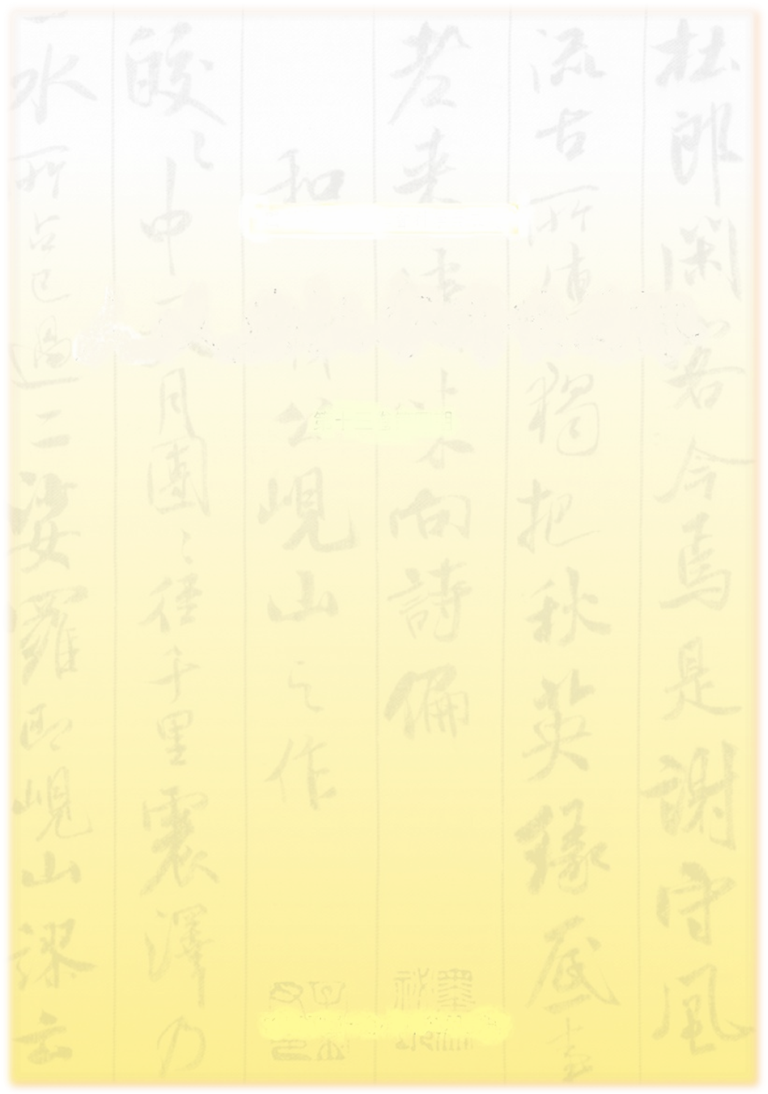

Dear Director/Professor：
This is a letter of invitation from the editor in chief of the Humanities and Social Sciences Newsletter (HSSN) published by the Department of Humanities and Social Sciences of the National Science Council in Taiwan. We appreciate you taking the time to read this e-mail.
Inaugurated in 1997, Humanities and Social Sciences Newsletter is a platform for academic exchange aimed at enhancing research and applications in relevant fields. Such exchanges have also encouraged multidisciplinary studies and achievement sharing over the years.
With the rising of Asia, the number of Centers of Chinese Studies and scholars who research Asian cultures and societies is growing year after year around the world. HSSN, published in Taiwan, is in a unique position to leverage the plethora of Chinese language literature from the best preserved 5000-year Chinese culture in the world. In order to enrich the research resources for Centers of Chinese Studies in non-Chinese speaking countries, we have launched a project to reconfigure the papers published in HSSN into e-books according to specific topics.
The e-books are free for researchers and students of your institute. Interested readers can simply click the link: http://www.nsc.gov.tw/hssnq and read the articles.
Enclosed please find the links of our first three e-books. We cordially invite you to use our digital resources. If you are interested in receiving more updated links of our publications in the future, please click “Subscribe” and provide your e-mail address in the reply. We will continue to send you the most updated e-books links to enrich your Chinese language research resources.

Sincerely,
Editor in Chief
Humanities and Social Sciences Newsletter
http://www.nsc.gov.tw/hum/lp.asp?CtNode=1146&CtUnit=815&BaseDSD=7&xq_xCat=%E3%84%95
E-mail：nsc.edit@gmail.com

Humanities and Social Sciences Newsletter E-books
01 | 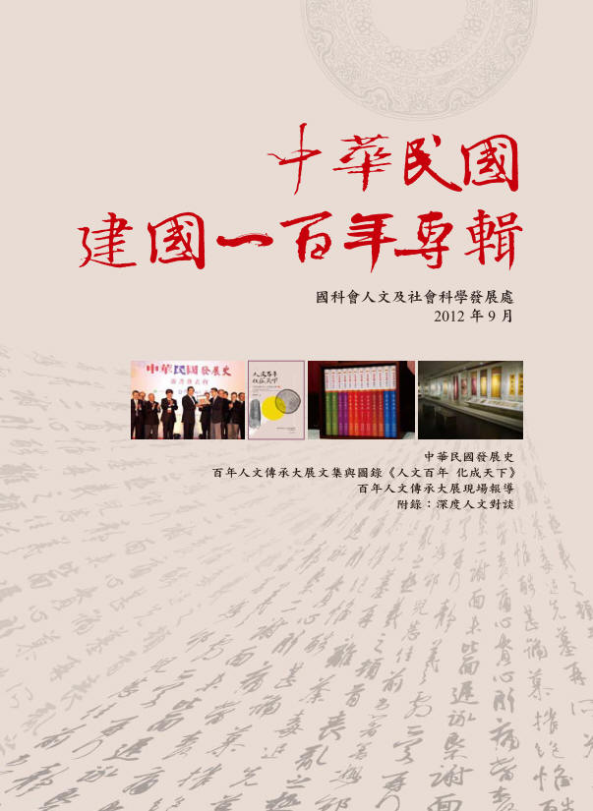 | e-book link：http://www.nsc.gov.tw/hssnq/ebook01/index.html
02 | 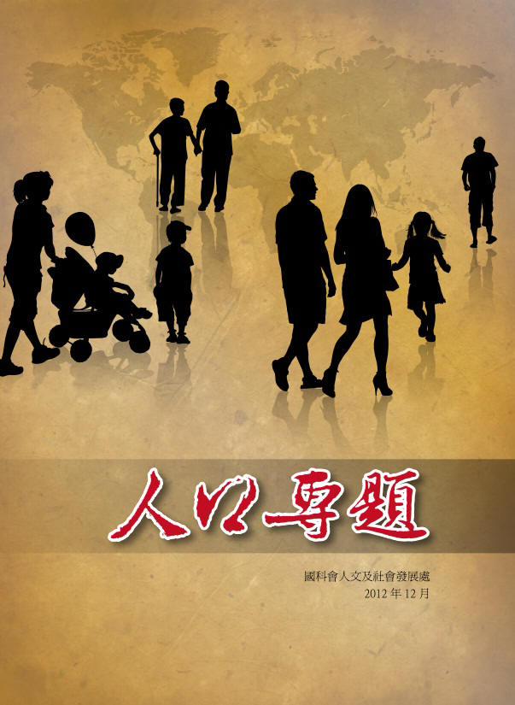 | e-book link：http://www.nsc.gov.tw/hssnq/ebook05/index.html
03 | 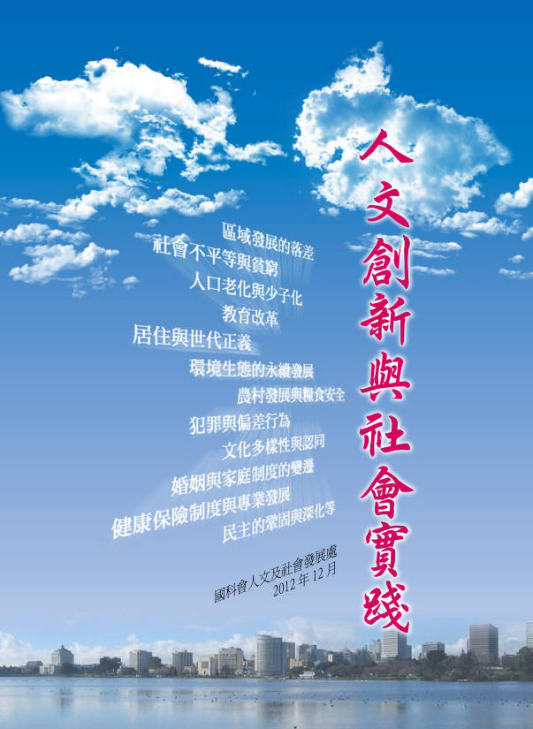 | e-book link：http://www.nsc.gov.tw/hssnq/ebook06/index.html

04 | 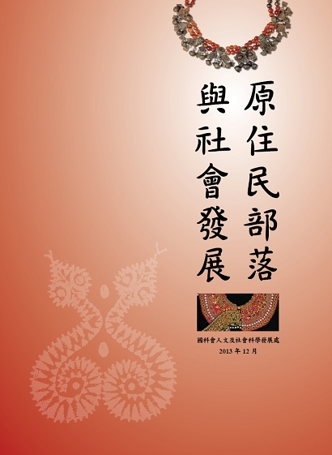 | e-book link：http://www.nsc.gov.tw/hssnq/ebook07/index.html
05 | 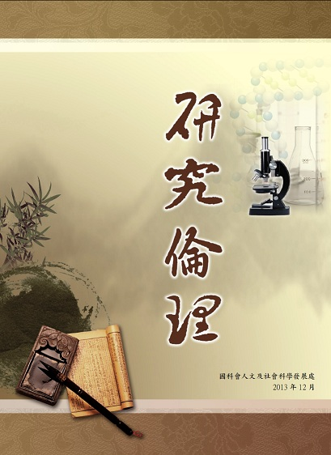 | e-book link：http://www.nsc.gov.tw/hssnq/ebook08/index.html
06 | 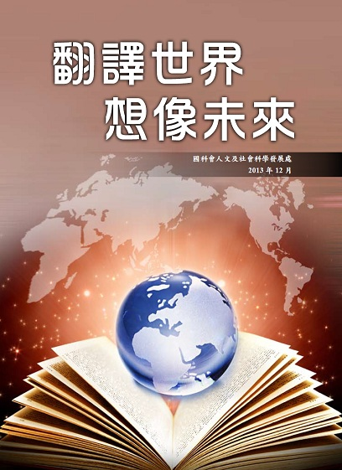 | e-book link：http://www.nsc.gov.tw/hssnq/ebook09/index.html

07 | 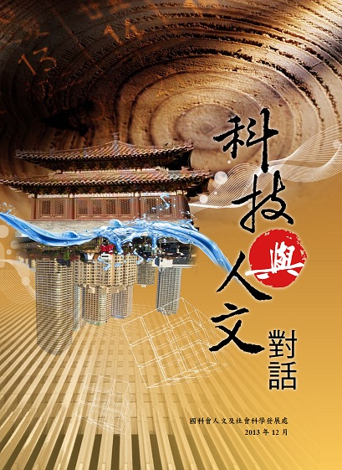 | e-book link：http://www.nsc.gov.tw/hssnq/ebook10/index.html

